Project Report Template

## INTRODUCTION

Customers who left within the last month-the column is called churn. Services that each customer has signed up for – phone ,multiple lines, internet, online security,online backup,device protection,tech support,and streaming TV and movies.

## PROBLEM DEFINITION & DESIGN THINKING

EMPATHY MAP

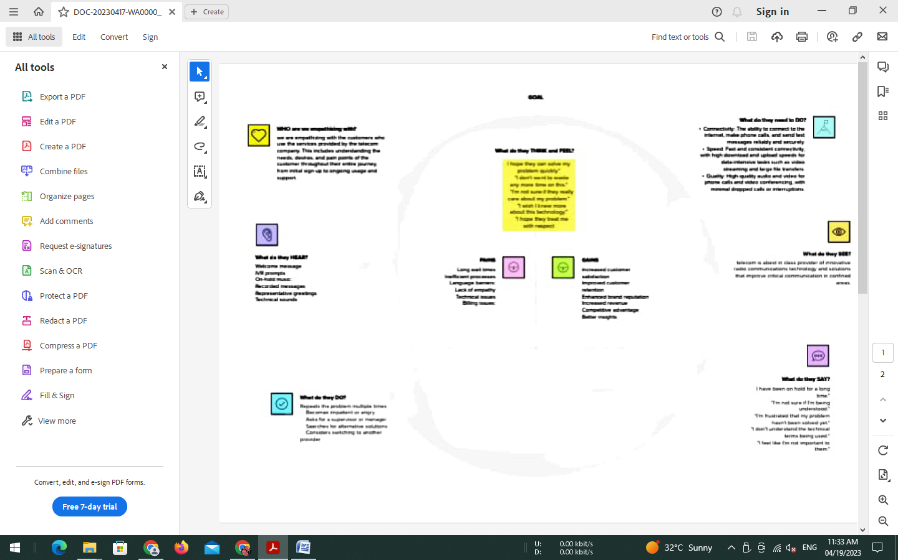

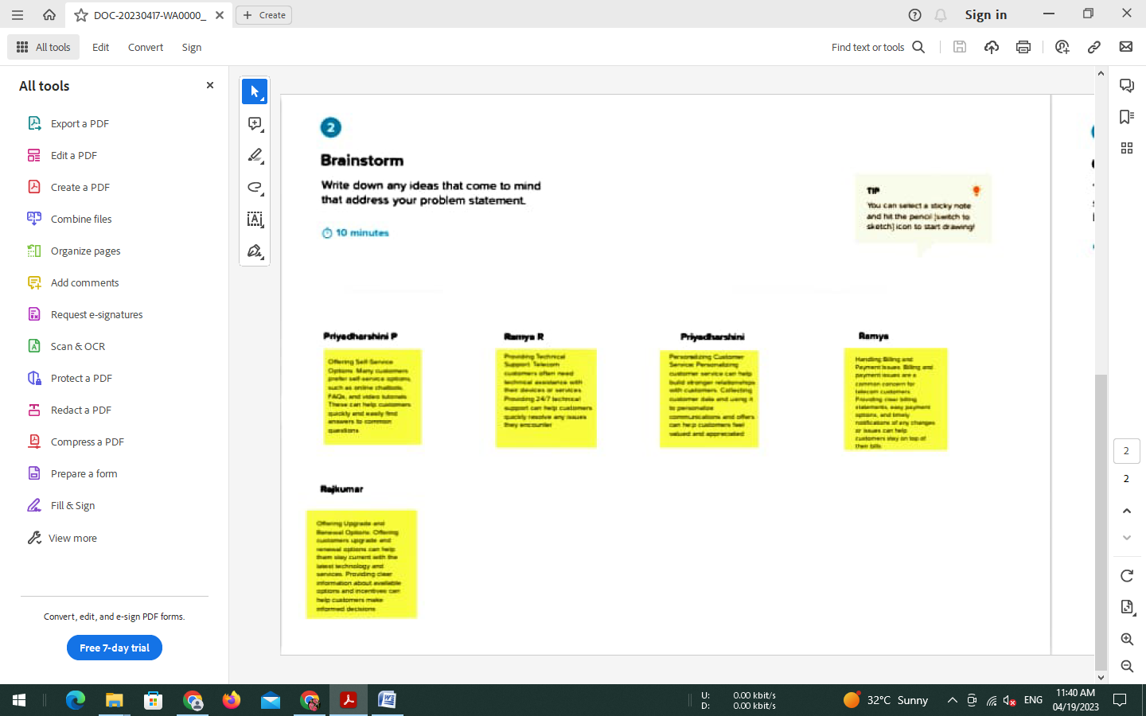

### RESULT

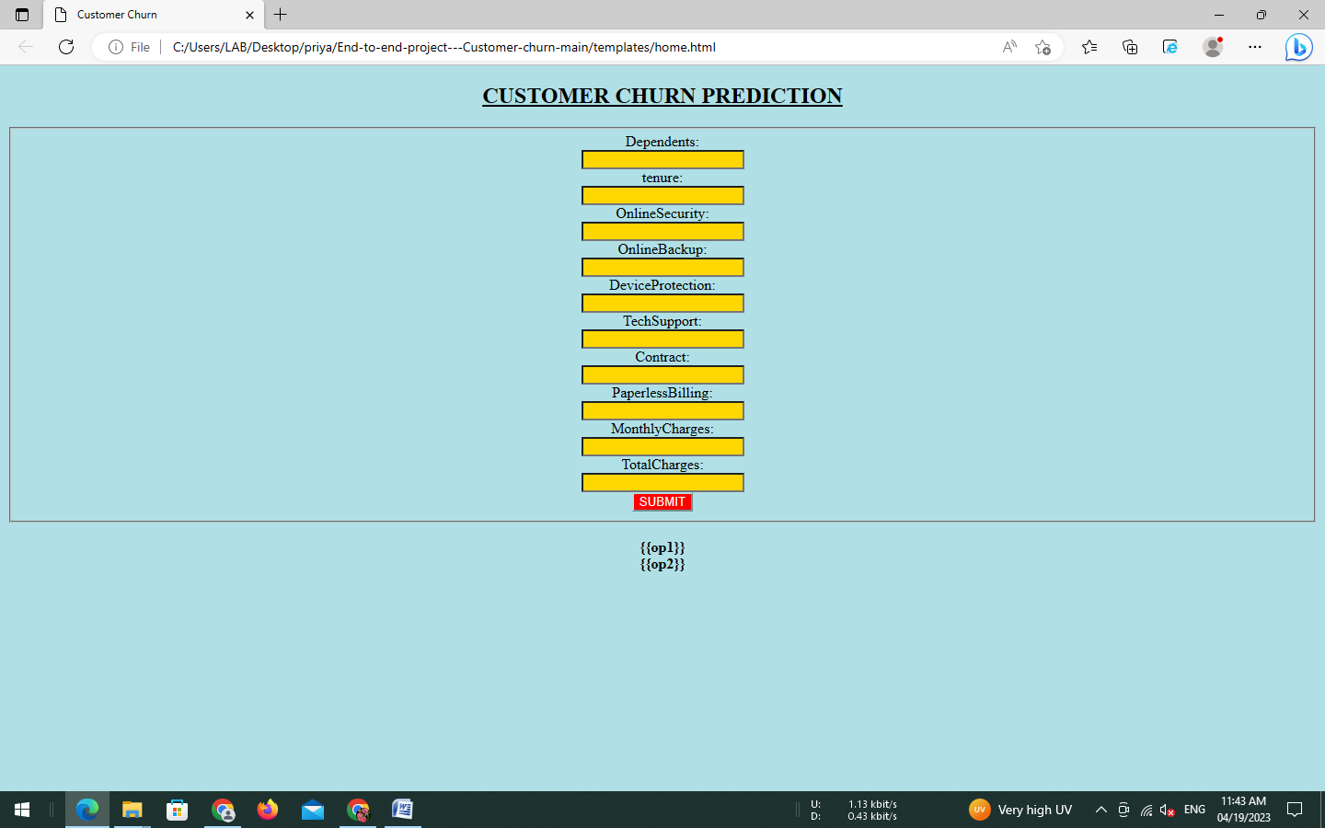

### ADVANTAGES & DISADVANTAGES

Customer churn analysis help businesses understand why customers don’t return for repeat business. Churn rate tells you what portion of your customers leave over a period of time it’s often useful to looks at churn by product , region or other granuler factors.

### DISADVANTAGES

Reduces monthly or annually recurring revenue .lost customer equal lost revenue